Once again I find myself looking at labels from 3rd party manufacturers of supplements and I wanted to point out some things that may help our customers make better decisions about what they are putting in their bodies.

The Dietary Supplement industry has grown over the years. It is a multi Billion Dollar industry. Many supplement manufacturers want a piece of that pie. Some manufacturers have principles that guide them to balance profit with quality and then there are some that go for profit alone. From what I see there are more of the latter than there are the former.

NO they aren’t all the same. Sometimes I get frustrated because I sell supplements and in the minds of some consumers, that disqualifies me as a source of information because I’ve got a monetary conflict of interest.

We strive to make Max Muscle “THE place you can go to get good science based information about supplements and nutrition”. We won’t ever tell you something just to sell a product.

With that said, here are some things I recently noticed about a Branched Chain Amino product. Let’s call it brand X.

Many times manufacturers will use precious metals to highlight their BEST products versus their good products. So Platinum may be regarded as even more high-end than gold, silver, etc. Those things can mean something or they can be totally meaningless marketing terms depending on the integrity of the brand. The product I’m going to discuss is listed at the highest level of the precious metal category so you would expect it to only contain the best, purest ingredients.

Branched Chain Amino formulas can help reduce fatigue during a workout, reduce central fatigue syndrome for distance runners, start the recovery process and prevent muscle breakdown. The high leucine content can help stimulate the MTOR pathway for better muscle protein synthesis. These are all good benefits.
Here is a label from one of those 3rd party brands. For starters it has sodium and carbs. Not a pure Branch Chain Amino product. The glutamine is listed 2nd on the label meaning it is the 2nd most prevalent ingredient on that list. Leucine, Isoleucine and Valine are the branch chains. You would expect they would be 1,2 and 3. Glutamine is not expensive. Soy is also listed in an allergen warning.

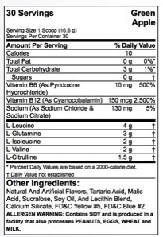

The second part of the label is here and this one tells another story about the quality. There is a warning on this one. In California there is a law that requires disclosure on Lead or HEAVY METAL content if it is above a certain threshold. This is called a Prop 65 Warning statement. This product has the warning on the label, which would indicate they are above the threshold.
This would indicate they are using an inferior quality
Branch Chain ingredient or ingredients. Brands like these do not have your health as a primary concern.

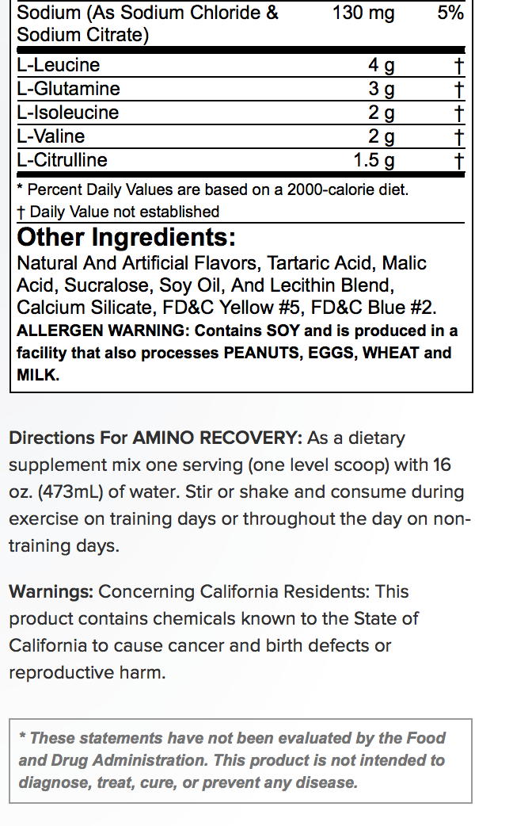
This is the label from the PRO BCAA product at Max Muscle. There is a big difference between this product versus the product highlighted above. You’ll also notice leucine, isoleucine and valine are listed as 1,2,3. No carbs added, no sodium, no soy. No prop 65 warning. And we haven’t even addressed how well these products mix or how well you digest them once you drink them. Those things make a difference in what your body can actually use.

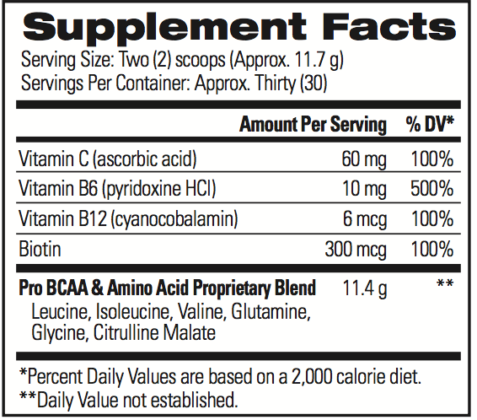

I hope you found this information to be useful. Please let us know if we can help you decipher labels when you have questions. You can’t always see what you need to on products but there are many hints if you know what you are looking for. We are trained to look.

Thank you,
Sincerely,
Scott Herkes
Certified Nutrition Coach
Co-Owner of Max Muscle Quad Cities

